## SIMATS ENGINEERING

**SAVEETHA INSTITUTE OF MEDICAL AND TECHNICAL SCIENCES CHENNAI-602105**

**CAPSTONE PROJECT REPORT ON**

**“RFID Reader for Inventory and Element Tracking”**

Submitted By

**K. Umesh Chandra (192210308)**

**C. Janardhan Reddy (192211819)**

**Faculty Name**

**Dr.Shri Vindhya**

# **Introduction:**

The "RFID Reader for Inventory and Element Tracking" focuses on enhancing the efficiency of inventory management by integrating RFID technology, a powerful tool for real-time tracking and monitoring. This project aims to automate the process of locating and managing inventory items, reducing human errors, and providing accurate, up-to-date information on item status and movement across the facility.

**Existing System drawbacks:**

1. **Time-Consuming** – Manual scans and checks require a lot of time and are prone to human error, especially in large inventories.
2. **Limited Range** – Barcodes and older RFID systems need close range and line-of-sight, which limits efficiency and flexibility.
3. **No Real-Time Updates** – Inventory data updates are often delayed, resulting in inaccurate stock levels and mismanagement.
4. **High Labor Costs** – Manual inventory checks increase staffing costs and take employees away from other tasks.
5. **Scalability Issues** – As inventory grows, traditional systems become harder to manage, leading to inefficiencies.
6. **Weak Data Security** – Older systems lack encryption, making data vulnerable to theft or tampering.
7. **High Maintenance Costs** – Outdated hardware and software need frequent repairs and replacements, increasing expenses

**Problem Statement:**

Traditional inventory and element tracking methods, such as barcodes and manual data entry, face significant limitations in today’s fast-paced operational environments. These methods are labor-intensive, time-consuming, and prone to human error, requiring close range or line-of-sight scanning for each item. Such systems also lack real-time tracking capabilities, leading to delayed inventory updates and inaccurate stock records. As businesses scale, these limitations hinder efficiency, drive up labor costs, and make inventory management challenging.

RFID technology allows fast and accurate data capture, improving operational efficiency and reducing dependency on manual labor. By providing secure and scalable inventory tracking, this system enhances data accuracy, supports larger inventories, and reduces costs. This RFID solution will ultimately improve asset visibility, streamline workflows, and contribute to better resource management across industries.

**Definition:**

RFID Reader for Inventory and Element Tracking involves using RFID technology to automate the tracking of inventory and assets. RFID readers capture data from tags attached to items, allowing for real-time, accurate tracking without the need for line-of-sight scanning. This system improves efficiency, reduces human error, and enhances inventory management.

**Proposed Methodology:**

1. **System Design and Planning:**  
   The system architecture is designed, selecting appropriate RFID tags and readers, and defining the necessary network infrastructure for data transmission. This ensures that all components work together seamlessly.
2. **Tagging Inventory Items:**  
   Each item is tagged with a unique RFID label, enabling individual identification for real-time tracking. This step ensures that all inventory is accounted for and traceable.
3. **RFID Reader Deployment:**  
   RFID readers are strategically placed at key locations to continuously scan and capture data from tagged items. This provides real-time tracking and updates as items move within the inventory.
4. **Data Capture and Integration:**  
   Data from RFID readers is sent to a centralized database, updating stock levels and tracking item movement. This data is integrated into existing inventory management systems for seamless updates.
5. **Real-Time Monitoring and Reporting:**  
   The system provides live updates on inventory status, including item location and movements. Automated reports are generated to assist in decision-making and inventory management.
6. **Security and Data Encryption:**  
   Communication between RFID tags and readers is encrypted to ensure data security and prevent unauthorized access. This protects sensitive inventory information from potential threats.
7. **System Testing and Optimization:**  
   The system undergoes rigorous testing to ensure accuracy and efficiency. Adjustments are made to optimize performance, such as repositioning readers and fine-tuning data handling processes.

**System Architecture:**

1. **RFID Tags:**  
   Each item is tagged with a unique RFID label that stores key information like item ID. These tags send data when scanned by an RFID reader.
2. **RFID Readers:**  
   RFID readers are placed at strategic points to scan the tags and capture information, such as item ID and location, in real-time.
3. **Data Transmission Layer:**  
   The data from RFID readers is sent to a central system over a network, ensuring real-time updates and accurate tracking.
4. **Centralized Database/Server:**  
   The system stores all data from the readers, like inventory levels and item locations, in one place for easy access and management.
5. **Inventory Management Software:**  
   This software uses the stored data to help manage inventory, update stock levels, and create reports automatically.
6. **Security Layer:**  
   Security measures, like encryption, protect the data and ensure that only authorized users can access it.
7. **User Interface (UI):**  
   A user-friendly dashboard displays real-time inventory status, item locations, and reports, making it easy to manage and monitor.

**Module Description:**

1. **RFID Tagging Module:**  
   This module assigns unique RFID tags to each item, allowing for easy identification and tracking.
2. **RFID Reader Module:**  
   RFID readers scan tags to collect data like item ID and location, sending it to the system in real-time.
3. **Data Transmission Module:**  
   This module securely transmits the data from RFID readers to the central system, ensuring real-time updates.
4. **Inventory Management Module:**  
   It uses the data to update stock levels, track movements, and generate reports, helping to manage inventory efficiently.
5. **Database Module:**  
   The database stores all item data, including stock levels and movements, ensuring quick access and reliable storage.
6. **Security Module:**  
   It protects data with encryption and controls user access to ensure secure handling of sensitive inventory information.
7. **User Interface (UI) Module:**  
   The UI provides an easy-to-use dashboard for monitoring inventory, viewing real-time updates, and generating reports.

**Working Principle Layout:**

1. **Tagging Items:** Each item in the inventory is assigned a unique RFID tag. These tags contain data such as item ID, description, and other relevant details. The tags are attached to the items to allow easy tracking.
2. **Scanning Items:** RFID readers are strategically placed in the inventory area (e.g., shelves, entry/exit points). When an RFID-tagged item enters the reader’s range, the reader scans the tag and captures its unique ID and other relevant data.
3. **Data Transmission:** The RFID reader sends the captured data, including item ID and its location, to the central system (server or cloud database) via a wireless or wired communication network. This allows for real-time updates on the inventory status.
4. **Data Storage:** The central system stores the received data in a database. It logs details such as item ID, stock levels, movements, and location, ensuring accurate inventory tracking.
5. **Inventory Management:** The inventory management system uses the data from the database to monitor stock levels, track item movements, and generate alerts for low stock or discrepancies. It can also generate reports for management.
6. **User Interaction:** The user interface (UI) allows authorized users to access the system. Users can view real-time inventory data, track item locations, manage stock levels, and generate reports through an easy-to-use dashboard.
7. **Security and Access Control:** The system ensures data security by encrypting communications between RFID tags, readers, and the central system. It also has user authentication to restrict access to sensitive inventory data.

**Implementation:**

1. **RFID Tagging and Labeling:**
   * **Step 1:** Choose the appropriate type of RFID tags (passive or active) based on the inventory's needs.
   * **Step 2:** Attach the RFID tags to each item in the inventory. These tags will store a unique identifier (ID) and any other necessary data.
   * **Step 3:** Ensure that the tags are durable and positioned properly for effective scanning.
2. **RFID Reader Installation:**
   * **Step 1:** Install RFID readers at strategic locations such as entry/exit points, shelves, and storage areas to scan the RFID tags.
   * **Step 2:** Ensure the readers are within range of the tagged items, ensuring full coverage of the area.
   * **Step 3:** Connect the readers to the central system using wired or wireless communication methods like Wi-Fi or Ethernet.
3. **Data Capture and Transmission:**
   * **Step 1:** RFID readers scan the tags and capture data such as item ID, timestamp, and location.
   * **Step 2:** The captured data is sent to a centralized database or server in real-time via a secure transmission network.
4. **Database Setup:**
   * **Step 1:** Set up a centralized database or cloud system to store the data from RFID readers.
   * **Step 2:** Ensure the database can handle large volumes of data and supports fast retrieval and updates.
   * **Step 3:** Design the database schema to store information such as item IDs, stock levels, and item movement logs.
5. **Inventory Management Software:**
   * **Step 1:** Develop or integrate inventory management software that connects to the database.
   * **Step 2:** Implement features for real-time tracking of inventory, including viewing stock levels, item locations, and automated alerts for low stock.
   * **Step 3:** Allow for report generation, providing insights into inventory trends, stock movements, and discrepancies.
6. **User Interface (UI) Development:**
   * **Step 1:** Create a user-friendly interface (web-based or desktop application) that displays real-time data about the inventory.
   * **Step 2:** Include features such as inventory tracking, search functionality, and report generation.
   * **Step 3:** Implement login and user authentication to restrict access to authorized personnel only.
7. **Security Implementation:**
   * **Step 1:** Use encryption protocols (such as SSL/TLS) to secure data transmission between RFID readers, tags, and the central system.
   * **Step 2:** Implement access control and user authentication to restrict access to sensitive inventory data.
   * **Step 3:** Regularly update security measures to protect against data breaches and unauthorized access.
8. **Testing and Optimization:**
   * **Step 1:** Conduct comprehensive testing of the entire system to ensure RFID tags, readers, database integration, and software work seamlessly together.
   * **Step 2:** Test for real-time tracking accuracy, system response time, and data integrity.
   * **Step 3:** Optimize the system for better performance, adjusting reader placement, data transmission speed, and UI responsiveness based on feedback.
9. **Deployment and Monitoring:**
   * **Step 1:** Deploy the system across the inventory management facility.
   * **Step 2:** Continuously monitor the system's performance, tracking any issues related to RFID reading, data transmission, or database updates.
   * **Step 3:** Regularly update the system to handle larger inventories or adapt to new business requirements.

**Output:**

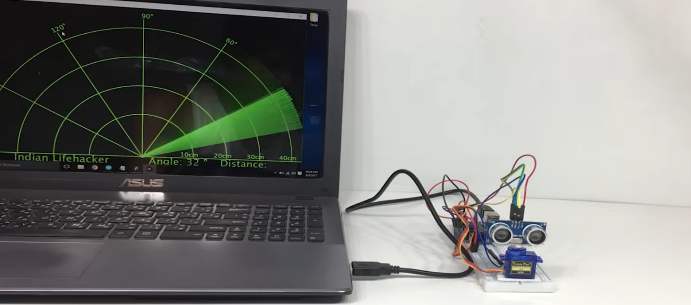

**Figure 1. RFID Reader for Inventory and Element Tracking before an Object is placed**

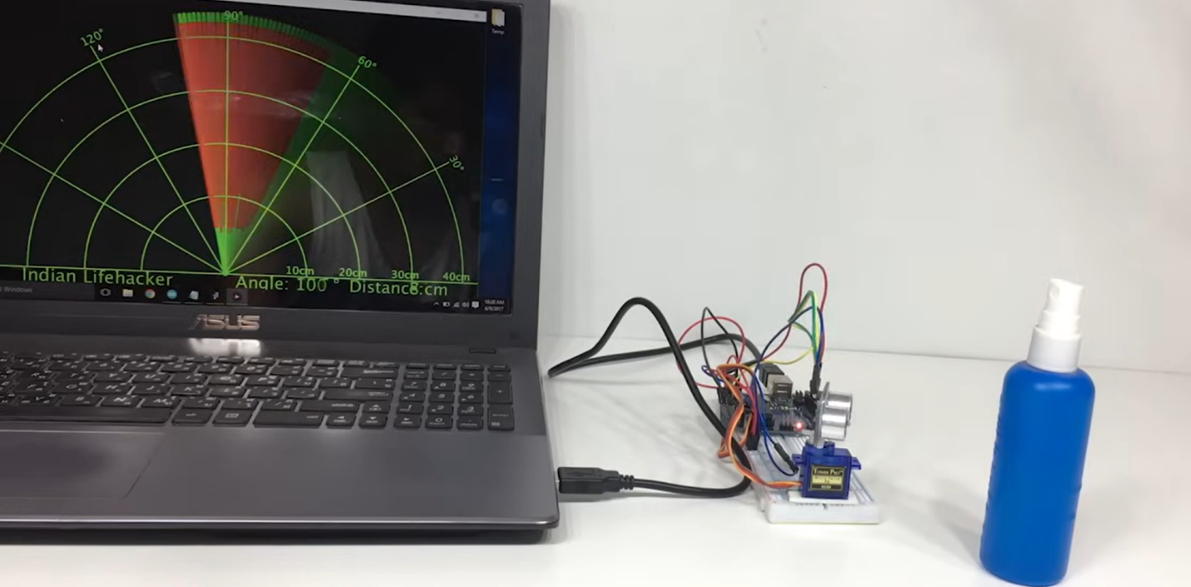

**Figure 2. RFID Reader for Inventory and Element Tracking Product design after Object is placed**

**References:**

1. **Finkenzeller, K. (2010).** *RFID Handbook: Fundamentals and Applications in Contactless Smart Cards and Identification*. Wiley.  
   This book offers a comprehensive understanding of RFID technology, including its applications in inventory management.
2. **Want, R. (2006).** *An Introduction to RFID Technology*. IEEE Pervasive Computing, 5(1), 25-33. This paper provides an introduction to the principles, working, and applications of RFID technology.
3. **Lee, J., & Kwon, H. (2014).** *RFID-based Inventory Management System for Smart Warehouse*. International Journal of Advanced Science and Technology, 70, 65-76. This research article discusses an RFID-based inventory management system with a focus on warehouse operations.
4. **Zhou, W., & Lee, J. (2008).** *RFID-based Inventory Management System: Architecture, Applications, and Future Prospects*. International Journal of Production Research, 46(23), 6627-6643. This paper examines the architecture and applications of RFID technology in inventory management.
5. **Roussos, G., & Mylonas, A. (2015).** *Inventory Control with RFID*. In *Proceedings of the 15th International Conference on Information Systems & Design of Communication (ISD)*. This conference paper focuses on the integration of RFID systems into inventory control and management.
6. **Bhattacharjee, S., & Jha, S. (2014).** *RFID-based Inventory Management System for E-commerce Application*. International Journal of Computer Applications, 96(19), 20-25. This paper discusses an RFID-based inventory system applied to e-commerce, which can be adapted for physical stores or warehouses.
7. **Liu, X., & Zhang, W. (2010).** *Design of RFID-based Warehouse Management System*. Proceedings of the International Conference on Computational Intelligence and Software Engineering. This paper provides a detailed design of a warehouse management system utilizing RFID technology for inventory tracking.
8. **Schuster, J., & Fransen, R. (2010).** *RFID for Inventory and Asset Management*. *The Journal of the Textile Institute*, 101(4), 324-329.  
   This article reviews RFID applications in inventory and asset management, particularly in industries such as manufacturing and retail.
9. **Glover, B., & Bhatt, A. (2009).** *RFID for Dummies*. Wiley Publishing.  
   This is a practical guide to understanding and implementing RFID technology, including its use in inventory management systems.
10. **Cisco Systems (2011).** *RFID in Supply Chain and Inventory Management*. Cisco White Paper. This white paper from Cisco explores the use of RFID technology for enhancing supply chain operations and inventory management.

**Conclusion**

Implementing an RFID Reader for Inventory and Element Tracking introduces various challenges, including RFID detection accuracy, real-time data processing, scalability, and user interface design. By breaking down the project into manageable components and applying modular and object-oriented programming principles, this system can achieve high efficiency and adaptability. The result is an effective, scalable solution for automated inventory management and tracking.

**Future initiatives:**

1. **Predictive Inventory with AI and IoT:**  
   Future systems could use AI and IoT with RFID to predict stock needs, automate orders, and prevent shortages, helping to manage inventory more effectively.
2. **Improved Data Security:**  
   Enhanced security, such as encryption and blockchain, will protect RFID data, ensuring secure, tamper-proof tracking throughout the supply chain.
3. **Real-Time Processing with Cloud and Edge Computing:**  
   Using cloud and edge computing will speed up data processing, allowing for instant updates on inventory even in large warehouses.
4. **Automated Inventory Counts with Robots:**  
   Robots with RFID readers could handle stock counts, reducing errors and saving time by automating the process.
5. **Standardized RFID for Cross-Company Tracking:**  
   Developing universal RFID standards will allow different companies to track items seamlessly across the supply chain.
6. **Eco-Friendly RFID Tags:**  
   Future RFID tags made from sustainable materials could reduce environmental impact and support green initiatives in inventory management.
7. **Precise Tracking with RFID and GPS:**  
   Combining RFID with GPS will allow for exact tracking of items in ware houses and during transportation, improving logistics.
8. **Mobile and Real-Time Dashboards:**  
   Mobile-friendly dashboards will let managers monitor inventory data in real-time from any location, enhancing flexibility and control.